Capsis 4 - Reference Documentation

Computer-Aided Projections of Strategies In Silviculture
F. de Coligny
v1.2 - Capsis 4.2.6 - August, 26 2019

http://www.inra.fr/capsis
Table of Contents
1 Introduction 4
2 Software architecture 5
3 The kernel 6
3.1 Main components 7
3.1.1 Engine 7
3.1.2 Pilot 7
3.1.3 Relay 8
3.2 Organisation in memory 10
3.2.1 Session 10
3.2.2 Project 10
3.2.3 Step 10
3.3 Superstructure of a module 11
3.3.1 GScene 11
3.3.2 GModel 12
3.3.3 InitialParameters 13
3.3.4 IdCard 14
4 Implementation of a module 14
4.1 SVN local copy / installer version 14
4.2 Package, classes, methods 15
4.3 Compilation and other commands 16
5 Additional generic data structure 17
5.1 Tree 17
5.2 Plot 18
6 Running a simulation 20
6.1 Capsis launching 20
6.2 Module initialisation 20
6.3 Evolution 22
6.4 Intervention 23
7 Extensions 24
7.1 ExtensionManager 24
7.2 GraphicalExtensionManager 25
7.3 Extension 26
7.3.1 Intervener 26
7.3.2 Memorizer 27
7.3.3 GenericTool 27
7.3.4 DataExtractor 28
7.3.5 DataRenderer 29
7.3.6 StandViewer 29
7.3.7 ObjectViewer 30
7.3.8 IFormat, OFormat 31
7.3.9 ModelTool 31
7.3.10 Other extension types 32
8 Standard features 32
8.1 PathManager 32
8.2 Settings storing and restoring 32
8.3 Log 33
8.4 Translator 33
8.5 Groups 34
8.6 MethodProvider 35
9 File organisation 36
9.1 Architecture on disk 36
9.2 Special files 37
9.3 Scripts 37
9.4 Libraries 38
9.5 Project saving on disk 38
10 The Capsis charter 39
10.1 Goals 39
10.2 Different actors 39
10.3 Capsis charter 39
11 References 40

Introduction

Capsis4 (Dufour-Kowalski et al., 2012) is a software platform for forest dynamics modelling. It hosts forest growth and yield or forest dynamics models and proposes tools to simulate interventions on the forest stands.

The accepted models may be of various types, including stand level models, individual based models with or without spatialisation, mixt models. They can rely on more or less detailed data structures (e.g. a tree may be individualised and optionaly spatialised).

Thus some models may concern a mono-specific stand as a whole to calculate the evolution of its main variables like stand density, spacing factor, mean tree or dominant tree characteristics, and other models may have a complete list of trees with each its species and may take into account the competition of trees for space, light or water.

All these models have in common to calculate the evolution of a forest stand, at least the growth of the existing trees, but sometimes also regeneration and recruitment, thinning, pruning, mortality.... They are all used with the goal to build silvicultural scenarios alterning stages of evolution and interventions (i.e. forest management actions like thinning).

To reach these goals, Capsis proposes a specific internal organisation based on a technical kernel and a list of modules: one for each growth model.

The kernel mainly manages the information in memory during the simulations. When Capsis starts, it creates a Session which will contain all the projects created by the user. When a Project is created in the Session, it is associated to a given growth model (a Capsis module), and an initial parameters configuration. At the end of the project initialisation, it contains a root Step carrying the initial state of the forest, resulting of the user choices.

The software expects few from the models. Concerning the forest data structure, it needs for each occurrence of the forest during the simulation an object implementing a specific GScene interface (here an interface as defined by the Java language, i.e. a data description) with few technical requirements only, mainly a date and accessors to handle the Step it is linked to.

The module can add all the extra information it requires, e.g. a list of trees with a specific type and a soil description, which properties can be specific and numerous if needed, they may be ignored by Capsis and treated only in module specific methods. Few interfaces are proposed to tell more to Capsis, e.g. that there is a list of trees, if they are individualised and if they are spatialised. These optional features can be useful to use generic tools (e.g. viewers and charts) which were made compatible with usual data structures (e.g. a list of trees with a diameter, an height, an age, an identifier...). The main objects of the module may 'publish' some of their properties this way, and of course they may have other properties of their own (e.g. crown base height, height of the first living branch...), completely ignored by the generic parts in Capsis. Specific tools may then be built in the module to show the state of these hidden properties if needed in charts or viewers, this can be done with Capsis extensions (i.e. plugins).

The modeller can choose to rely on some proposed generic data descriptions (at least the very light GScene), and to add his own properties if needed, by using the capabilities of the Object Oriented Programming (OOP), in particular inheritance. The only requirements of Capsis are a short list of functions (or 'methods') to initialise a project and trigger an evolution stage. The evolution method is requested by the GModel interface, it will create successive states of the scene and Capsis will store them in the Project, under new Steps linked to the root Step.

The technical skills required to work in Capsis are proposed to the candidate modeller in an initial training session, followed by a starting working session to build together a prototype of his simulator. This usual close starting support may be difficult or impossible for foreign modellers, this documentation may help them work by themselves with only email exchange with the Capsis team developers.

Software architecture
The architecture of Capsis4 relies on a technical kernel, modules for the growth models, separated pilots (interactive, script...) to handle the simulations, it also has extensions (i.e. plugins), which can be built and added at any time, compatible with a set of modules or only with a specific module.

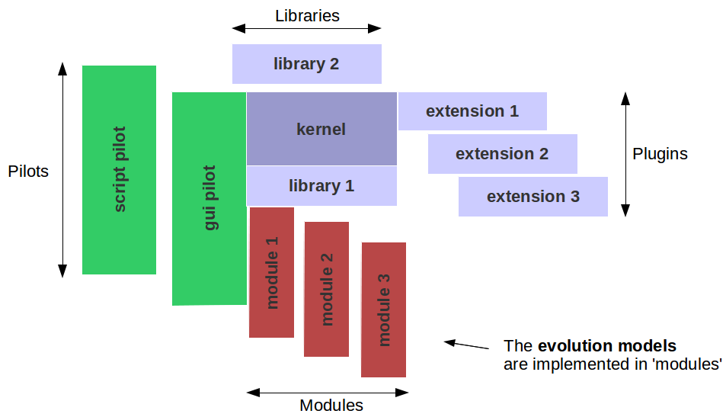
Fig 1. Capsis4 software architecture.
One of the main principles of the Capsis4 architecture is the possibility of specialising generic data structures in modules. This feature requires an Object Oriented Programming (OOP) language to benefit from the essential inheritance concept. Capsis4 was developped in Java.

The kernel is the core of Capsis4. It provides the basic operations of the software, like loading the modules and managing the simulations in memory. The features of the kernel are available to all components in Capsis4, including modules and extensions.

Capsis4 is used through a pilot. It is a set of classes used to run simulations relying on the kernel capabilities. The two main pilots are the interactive pilot (named gui) to handle the dialog with the user through a graphical user interface, and the non interactive pilot (named script), running simulations without user interaction, by executing a prepared script.

A Capsis4 module is the practical implementation of a forest dynamics model with data structures, methods (in Java, functions are named methods) and algorithms in a set of so called functionnal classes (in Java, source code is written in classes). These classes contain the knowledge of the modeller.

Modules are accompanied by a set of classes part of its relay, to complement or replace some classes in the generic pilot. E.g. an interactive relay will make it possible to use the module with the gui pilot, it will contain dialog boxes to handle the module initialisation and then to run simulation until a target time. It is possible to reduce the number of needed classes by relying on automatic relays with few conventions.

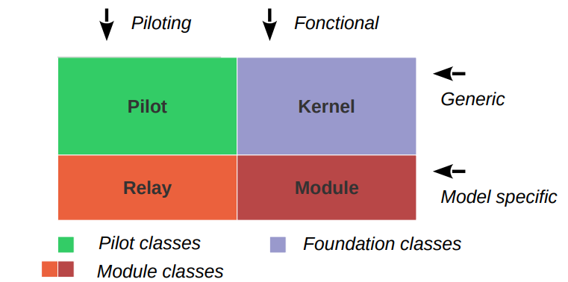
Fig 2: A focus on the Capsis4 kernel.

The extension framework can be used to add new features in Capsis4. The extensions are compatible with a set of modules or with one only. It is possible to build reusable extensions checking with Java interfaces if the needed features are available in the candidate module data structure, e.g. spatial tools or viewers will check if the scene is composed of a list of spatialised trees. Existing extensions can be used by new modules by implementing the expected interfaces. New extensions can be added at any time.

Various types of extensions exist for various needs, like simulated data extraction and displaying, filtering for lists of objects, data importation or exportation...

Capsis can check the compatibility of theses extensions with the modules, building lists of compatible tools on the fly in the interactive pilot.

The kernel
The main features proposed by the Capsis4 kernel (package capsis.kernel) are described here. They are accessible to all the Capsis4 pilots, proposing user interaction or not. The kernel has main components, specific classes for the organisation of the simulations in memory and generic data structures for the modules superstructure.

Main components

Engine
Capsis4 has a single object of type Engine (capsis.kernel). This object is a technical component, often invisible. The Engine has the reference to the single Session containing the Projects. It is constructed at the very beginning of the Capsis starting process (by the Starter class).

Engine takes care of building the pilot, manages the main configuration, deals with the Logs creation, knows the ModelManager and the ExtensionManager, initiliases the Translator and knows the application version and (SVN) revision number. It contains key methods to manage Projects and Steps (see below).

From everywhere in the source code, the Engine instance can be retrieved by Engine.getInstance ().

Pilot
At runtime, the user runs simulations in Capsis4 through a pilot. The pilot is chosen at start time, it is created early and is then available for the user. Two main pilots are provided: the gui interactive pilot and the script pilot for batch processing (without user interaction).

The gui pilot (package capsis.gui) is a set of graphical components, with a central MainFrame. This main frame proposes menus to choose a particular module, create and intialise a project with its root Step. Then, the project manager and a step popup make it possible to trigger evolution stages or interventions to create new Steps in the simulation.

The script pilot requires the writing of a Capsis4 script, based on the C4Script class.

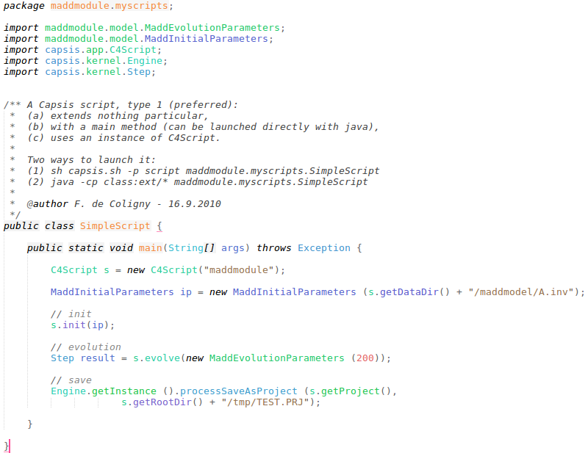
Fig 3: A simple example of script, relying on the maddmodule sandbox model.

Relay
The relay is a component between a given pilot and a given module. The pilot talks to the relay which answers directly (if interactive, possibly after opening a dialog box to ask the user), or transmits the request to the GModel object (for example when triggerring initialisation or evolution).
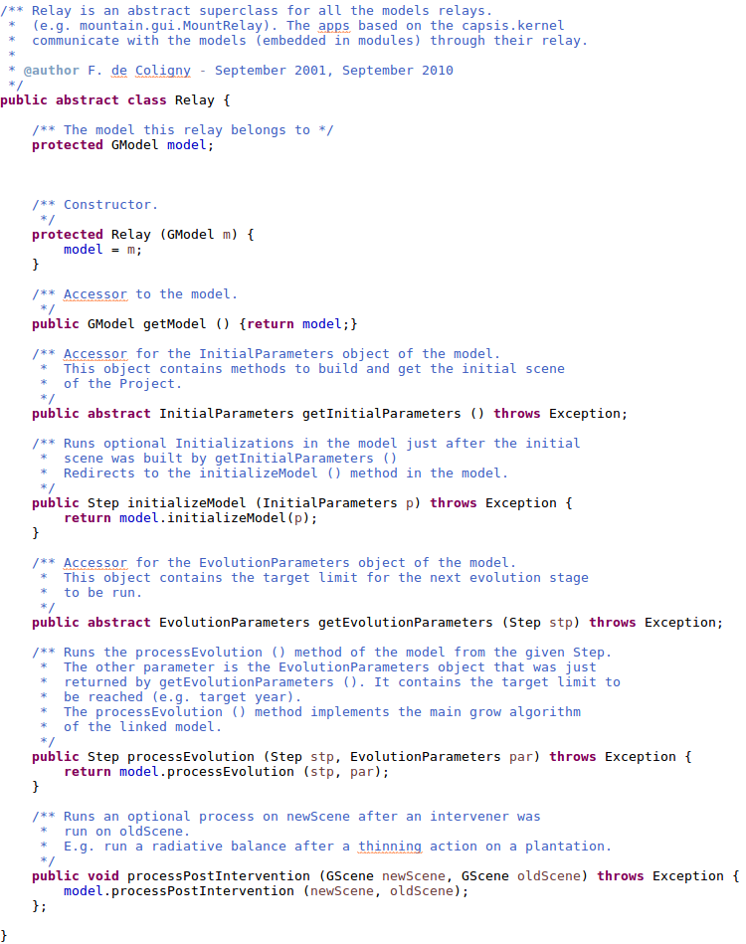
Fig 4: The capsis.kernel.Relay class with its expected methods for subclasses.

At initialisation time, the pilot calls in the relay successively getInitialParameters () then initializeModel (). At evolution time, it calls successively getEvolutionParameters () then processEvolution (). After an intervention, it calls processPostIntervention ().

The Relay for the gui pilot is capsis.commongui.DefaultRelay, it tries to find the InitialDialog and EvolutionDialog class names with conventions, see GModel.getInitialDialogClassName () for an example.

The Relay for the script Pilot is capsis.script.DefaultRelay.

Relay calls are generally hidden in other Capsis components, e.g. the gui pilot classes and the script superclasses (in particular C4Script).

Organisation in memory
Capsis4 handles Projects, composed of successive Steps, and grouped in a working Session. Each project has a model linked with a given set of parameters, initialised during an initialisation stage.

Session
The Session class (capsis.kernel) has a list of Projects. It is possible to add or remove Projects with the proposed methods. The Session has a name (at least a default name, based on the model name) and has other properties, e.g. relative to its saving on disk...

There is one Session only in Capsis, it contains all the Projects, its reference is hold by the instance of Engine.

Project
The Project (capsis.kernel) is linked to a given model with its set of parameters. Several Projects may coexist in the Session, linked to various models or linked to the same model but with different sets of initial parameters.

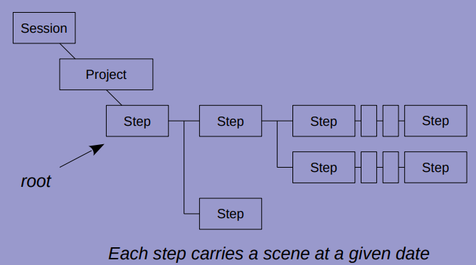
Fig 5: Session, Project and Step.

At the end of its initialisation, a Project has a root Step which can not be deleted. This root Step carries the forest initial state, resulting from the Project initialisation (file loading, virtual generation...). It is then possible to create other Steps in memory by triggerring the evolution method of the model or by running an intervention (an intervention is an extension, e.g. cutting trees). Alterning evolution stages and interventions results in a silvicultiral scenario with all successive states of the forest kept in memory under Steps.

A Project may contain several silvicultural scenarios having the same root Step but with alternative silvicultural management strategies.

Step
The Step class (capsis.kernel) describes a simulation step in Capsis4, it carries a scene (GScene class) calculated by the model linked to the Project at a given date (at initialisation time or later), or resulting of an intervention. The Project has at least one Step: the root Step resulting from the Project initialisation.

Steps are linked together. Each Step has a reference to its predecessor. All Steps have a reference to their Project.

To create new steps or iterate on existing steps, see the steps handling methods in Project.

Note: depending on Capsis4 memorisation options (Memorizer class), all steps may not be kept to save memory. The DefaultMemorizer keeps all steps.

Superstructure of a module

GScene
The scene is a snapshot of the user data structure (generally a forest) at a given date. Its description: capsis.kernel.GScene is kept light to let freedom to the modeller, but it proposes few common features:

- a method to get the Step carrying the GScene ;
- a date (e.g. a year, a number of years or months since the root Step, a rank 1, 2, 3...) ;
- an optional Plot object with information on the geometry of the scene, e.g. a rectangular plot containing square cells, knowing which trees they contain, and with neighbourhood searching capabilities (RectangularPlot / SquareCell). When no geometry is to be associated to the scene, a DefaultPlot may be used ;
- a helper method for evolution time: the getEvolutionBase () method may return a copy of the GScene, more or less complete depending on the model structure. This method will be used in the method implementing the evolution loop (see GModel.processEvolution () lower). For models having a scene class with a light memory footprint, an accurate copy (clone() of the GScene object) can be returned, and the properties of this copy will be adapted for the new Step. In other cases where the scene is heavier in memory (e.g. thousands of complex objects), a lighter copy could be returned, it will be completed immediately after, e.g. by looping on the original data structures (e.g. trees) to compute new objects with the new measurements to be added inside for the new Step ;
- a similar method named getInterventionBase () for intervention time, returns an accurate copy of the GScene object, to be altered by the intervention process (e.g. trees may be removed) ;
- other properties (is it the initial scene in the project, or the result of an intervention, its area in square meters, its date, the size of a bounding rectangle on the ground...).

GScene stands for generic scene, it is a Java interface, it can not be used directly. A default implementation is provided: SimpleScene (in capsis.defaulttype). This class can be used directly or subclassed in a particular module to add extra needed properties. A main subclass is proposed: TreeList (capsis.defaulttype) with a collection of individual trees (instances of capsis.defaulttype.Tree) for individual based models. TreeList implements the TreeCollection interface, proposing addTree (), removeTree (), getTrees ()...

GScene is intentionally kept simple to let the modeller add all he needs, generally in a subclass. Thus, very different data structures can be designed, with compartments completely ignored at the Capsis generic level, like for example a radiative balance or a soil description.

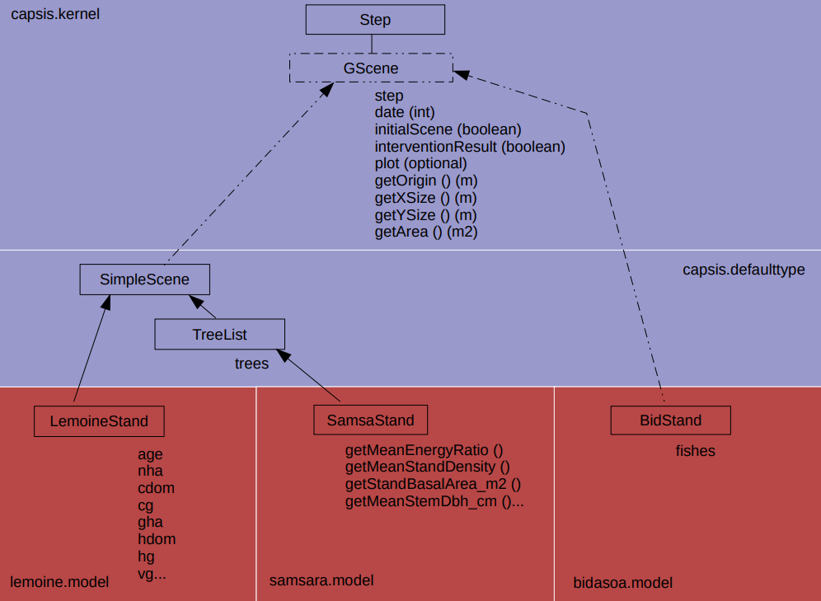
Fig 6: The GScene interface with its main subclasses and how they are used in three modules: Lemoine (stand model), Samsara (individual based model with trees spatialisation), and Bidasoa (experimental, fish dynamics in a river).

Note: a GScene instance should have no reference at all to another GScene instance: they are supposed to be ignoring each other and they should share nothing. As a matter of fact, these scene objects represent different states of the forest at different dates. For example, if there are 100 tree objects with age 10 and identifiers 1 to 100 under a scene dated 2000, the scene dated 2001 will contain 100 other tree objects with same identifiers and age 11. Once a GScene added under a Step in the Project, it is possible to find the previous scenes by exploring the previous steps.

GModel
GModel (capsis.kernel) is the superclass of all the model classes in Capsis4. Each module has its own model class, subclass of GModel, linked to the Project at runtime, and containing standard features:

- a reference to the model IdCard containing standard information for the module (model name, author name, model main class name...), it is used at model loading time by Capsis4 ;
- a reference to the InitialParameters object of the model, containing parameters which values are set at simulation initialisation time just before calling buildInitScne () (can be stored with the Project to ensure a restored project can continue simulations with the same initial parameter values) ;
- a reference to the linked Project: the GModel instance will be asked each time an evolution is requested in the Project ;
- can be stored to disk with the project and restored later ;
- contains the main methods initializeModel (), called at initialisation time, and processEvolution (), containing the evolution loop for the module, with new scenes creation and linking under new Steps in the Project.

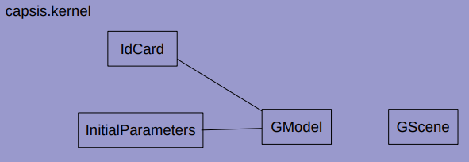
Fig 7: The main classes in a Capsis4 module: GScene is the scene state at a given date, the GModel with its IdCard and InitialParameters.

GModel does not propose any model implementation, but only methods in which the modeller will be able to implement his own model. In particular, the time step is free and time steps from one day to several years can be found in Capsis4.

The processEvolution () method generally loops according to the time step till the limit is reached and creates one or several scenes, stored under new Steps in the Project after the starting Step.

The only request during the 'evolution process' is that the method must be given a starting Step (which linked GScene is supposed to grow) and a limit for the growing process, e.g. a time limit (which type is chosen by the modeller at design time).

This structure gives a lot of freedom to the modeller to implement his model, with many sub compartments possibly ignored by Capsis4 if needed.

InitialParameters
InitialParameters (capsis.kernel) is an interface for the settings of the GModel in the Project. All modules have an object implementing InitialParameters in which the main configuration properties are gathered. All the values for these parameters are set at Project initialisation time and are kept unchanged for all the simulation time.

InitialParameters proposes the buildInitScene () method. This method must create the initial scene of the Project (file loading, virtual generation...), it is the first to be called at model initialisation time, just before GModel.initialize ().

It also keeps a reference to the initial scene which will be linked to the root step of the project, accessible by getInitScene ().

IdCard
Each model has an IdCard (capsis.kernel) containing information about the model and key management data to help load it in Capsis4.

Conventionally, there is a file named idcard.properties in all modules, e.g. samsara/idcard.properties. This file contains 10 lines with the values for 10 expected properties (free text in the IdCard should be in english):

- Name: free text, name of the module ;
- Author: free text, name of its author ;
- Institute: free text, name of the author's institute / company ;
- Type: free text, type of the model ;
- Prefix: conventional, prefix for all the classes in the model, starts with an uppercase letter, e.g. Sam for SamModel, SamScene... ;
- Package: conventional, name of the module package, all lowercase ;
- MainClass: conventional, name of the main class of the module, i.e. the model class, subclass of GModel, e.g. samsara.model.SamModel ;
- BundleBaseName: conventional, root name of the language bundle files: a couple of files with english and french translations for all labels written on the user interface ;
- Version: free text, the module version, e.g. 1.0 ;
- Description: free text, a short description of the module, in english (one sentence).

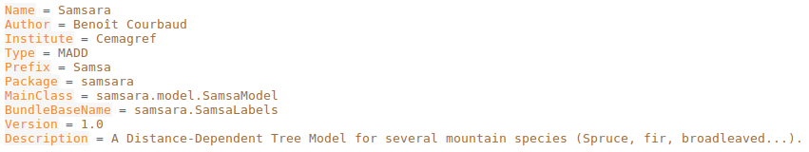
Fig 8: The samsara/idcard.properties for the samsara module.

The idcard.properties files are loaded by the ModelManager and stored in a map of IdCard objects. With this information, the ModelManager can load a model given its name (i.e. module package name, see the Module initialisation section).

Implementation of a module

SVN local copy / installer version
Depending on the user's role in the Capsis project, there are two ways of getting Capsis:

- the SVN local copy (subversion, source code versionning and sharing system) is available for developers and modellers of the Capsis project only, having accepted the Capsis charter. It contains all the source codes, gives access to compilation and makes it possible to publish the local changes when needed and occasionally gets the changes of the others through the project's SVN server ;
- an installer version is a partial distribution of Capsis. It contains all the freely distributable components in Capsis (kernel, pilots, libraries, extensions), plus one or several modules for which the author of the installer was granted to distribute them.
The preferred SVN client tool is SmartSVN, with is written in Java and can be used under Windows, Linux and macOS.

The Capsis modellers work in their own SVN local copy. They are helped at start time (to get the local copy, create the module's skeleton, design the new classes and methods...). Then they may continue by themselves if they feel enough at ease, or request extra working session together with a developer if they prefer.

Package, classes, methods
A growth model in Capsis4 is implemented in a module of the application. Each module has a name (matching a package / directory name in which all its source codes are stored) and a prefix to recognize its classes easily. E.g. for the training model with its prefix Tra, the model class is training.model.TraModel, it is stored in capsisInstallDir/src/training/model/TraModel.java (see Superstructure of a module).

Each module must provide its version of the main module classes, by extending them: GModel, InitialParameters and GScene (IdCard is used directly, the field values are set by a file with a conventional name, see the IdCard section). The subclasses must provide implementations for the expected standard methods (e.g. buildInitScene () in InitialParameters, initializeModel () and processEvolution () in GModel...), and they can bring their own methods for specific processes.

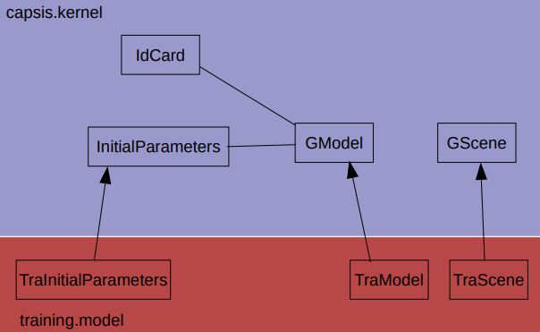
Fig 9: The main classes of the training module: extending the generic classes in the capsis.kernel.

At initialisation time, several methods will be called in the module in order:
- getInitialParameters () in the module's relay is responsible for setting the expected values in the InitialParameters list of variables (which all have default values). In interactive mode, this will open a dialog box to ask the user the values. In script mode, this stage is skipped and the values are set by program in the script or by reading an appropriate file ;
- InitiallParameters.buildInitScene () must create the root scene, often by reading a so called 'inventory file' containing detailed information on the state of the forest at simulation start date. Each module can have ist own inventory file format. Capsis proposes helper classes for reading these inventory files (FileReader / StandRecordSet). Some module may create a virtual scene instead of loading a file at this stage.
- GModel.initializeModel () is then called, it may do other module specific initialisations.

At evolution time, other key methods are called in the module:
- getEvolutionParameters () in the module's relay is responsible for setting the time limit for the evolution stage, e.g. a target date. The limit can be set differently depending on the modeller's choice, e.g. 'until the stand basal area reaches this target value'. Additional information can be set for the context of the evolution, e.g. 'mortality activated'. Like for getInitialParameters (), interactive mode generally opens a dialog box to ask the time limit to the user and in script mode, the time limit is set in the program or in a command file ;
- GModel.processEvolution () is passed the evolution departure Step and the time limit, it can loop, create the new scenes and store them in the project under new Steps.
After an intervention, the GModel.processPostIntervention () method is called in case the model would need an extra process. E.g. after tree cutting, some model may need to relaunch a radiative balance on the resulting scene to get an updated light map.
When implementing the module, the main methods InitialilParameters.buildInitScene (), GModel.initializeModel (), GModel.processEvolution () and GModel.processPostIntervention () must be overriden.

Compilation and other commands
The main commands needed for developing in Capsis have been automatized with ant. This tool runs commands described in its build.xml configuration file. ant has been embedded in Capsis and is available on all the modellers' machines. ant commands must be typed in a terminal from the capsis4/ directory. Simply type ant <command> under Windows, or sh ant <command> under Linux and macOS. Here are the main commands provided:
- ant compile: detects all source files in src/ needing compilation (class file not found or older than source file) and recompiles them in class/ with the javac compiler found in the system PATH variable ;
- ant clean: removes all the results of previous compilation stages (i.e. removes class/). After ant clean, ant compile recompiles averything. ant clean compile run the two commands in sequence ;
- ant compile-test compiles all the source files in test/ ;
- ant test runs all the tests, ant run-test -Dtest=full/TestName runs the given test ;
- ant create-module helps at project design time by copying and renaming a simple template module with a new module name and prefix ;
- ant jar creates the capsis-kernel.jar to be exported in other applications (e.g. AMAPstudio) ;
- ant installer creates an installer with Capsis and a given list of modules for distribution in accordance with the Capsis charter (the modellers need authorization to distribute the models of their colleagues) ;
- ant javadoc creates the complete javadoc of all classes in the project, including all Capsis and modules classes ;
- ant freeze freezes a given capsis.lib library by adding a given suffix then copies the resulting .jar file in ext/ ;
- ant redirect redirects a given module to a given frozen library ;
- and duplicate-module makes a copy of a given module with a new module package name and prefix, can be used at module creation time to help start a new project ;
- ant revision prints the current revision of Capsis.

Additional generic data structure

Tree
Tree (capsis.defaulttype) is an optional class to be used in individual based models. It describes a tree like an object, with few standard properties like an id (integer, unique in the scene), age (years), dbh (diameter at breast height, cm) and height (m). It knows the GScene instance it is part of and may have a reference to the ground Cell containing it if any in the module (see Plot and Cell optional objects).

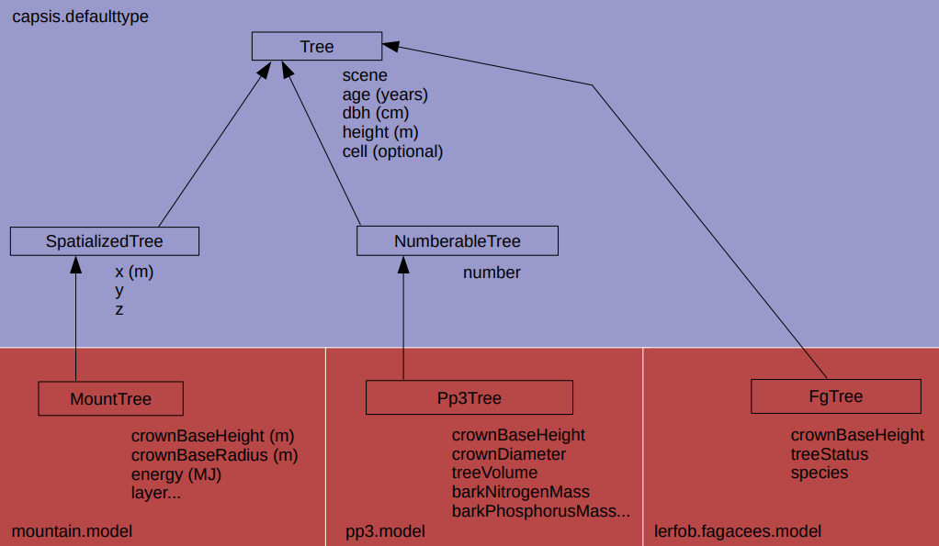
Fig 10: The Tree class, with 2 main subclasses: SpatializedTree for trees with coordinates, and NumberableTree if the tree is not individual and has a number. Some modules may extend directly Tree without using the proposed subclasses like Fagacees: individual, not spatialised tree. Some other modules may have no trees at all.

This data type is not mandatory for individual based models, but if used, generic tools may become compatible by detecting it. E.g. a TreeList containing instances of Tree may give access to viewers and charts showing the evolution of the basic properties in Tree over time.

Plot
In Capsis, the Plot (capsis.kernel) is optional: if not needed, a simple DefaultPlot is enough. The plot is a geometrical description of the stand: can be parted in ground cells knowing which trees they contain.

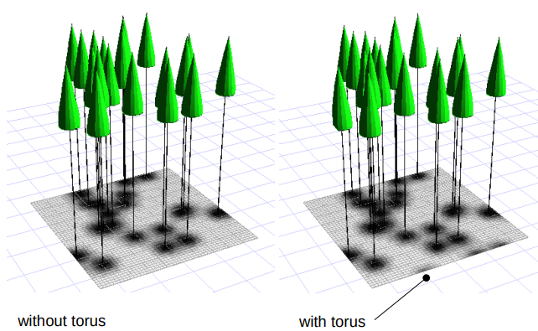
Fig 11: A RectangularPlot: looking at the neighbour cells without and with torus (Stretch, G. Vincent, IRD AMAP).

A RectangularPlot contains SquareCells. All cells have the same width. The cell knows its trees and additional properties can be added by extending SquareCell. The cells are in a matrix in the RectangularPlot and a feature is proposed to search neighbours of a given tree (or location) within a given distance. See the RoundMask class in capsis.defaulttype.plotofcells. The mask may consider the plot like a torus to avoid the edge effect (trees near the border would have less neighbours).

A PlotOfPixel contains Parcels containing Pixels. Unlike the RectangularPlot, it may be used with plots which are not rectangular. The neighbourhood system can search the whole plot or only some parcels (see PixelRoundMask). The elements in the Pixels may not be trees but anything Spatialized (i.e. having coordinates).

A PolygonPlot contains PolygonCells, they can be used for stands parted in polygons like management units. They do not have the neighbourhood features.

The Plot object can be accessed from the GScene instance by getPlot (). In return, Plots have a getScene () method to get the connected GScene instance.

Plots have a set of standard methods to get simple information on their size: getOrigin () returns the point with the lowest coordinates, getXSize () and getYSize () return the width and height of the bounding rectangle on the ground, getArea () returns the plot area in m2. These methods can also be found in GScene, with redirections to the plot methods, see SimpleScene.

Running a simulation

Capsis launching
The Capsis4 application is launched by the capsis.app.Starter class in a terminal through a script: capsis.bat (Windows, type only capsis) or capsis.sh (Linux and macOS, type sh capsis.sh). The script accepts parameters and passes them to the Capsis Starter.

Capsis only needs the PATH system variable to refer to the expected version of Java (e.g. Java 1.8 in August 2019). The script is supposed to be launched from the Capsis4 installation directory (installDir/). This way, it can build dynamically the classpath: installDir/class/ contains all the compiled classes and installDir/ext/ contains all the external libraries in .jar files.

A default amount of heap memory (where the objects are stored at runtime) is selected at start time in the script. It is possible to change this memory amount (in Mb) to require more or less, in accordance with the available amount of memory, by using the setmem.bat / setmem.sh scripts. E.g. to require 4 Gb memory for the simulations under Windows: setmem 4096.

To know the options available at Capsis4 start time, try the option -h, e.g. under Windows: capsis -h

By default, typing only capsis (or sh capsis.sh) will start Capsis in interactive mode (gui pilot), using the language detected on the operating system (french or english only).

To start Capsis explicitly in interactive mode and english, try capsis -p gui -l en

The Starter class contains the main () method of the application, the one invoked by the script. It can be called only once (otherwise it returns immediately). It then in order:

- detects and prints the OS, JVM architecture and memory, e.g. OS/JVM/memory: linux/64/8000m ;
- interprets the arguments with the Option class: reads the SVN revision, sets the Locale (language for the graphical user interface if used), checks the pilot name, ensures standard directories exist or creates them, creates the Log, loads the property files, prints the properties in the Log (var/capsis.log) ;
- prints the Capsis4 short notice in the terminal ;
- creates the ExtensionManager ;
- builds the Engine: inits the Translator, creates the ModelManager, sets the Engine version and revision, creates the Pilot (if gui, the main frame appears), reports to the Log ;
- inits the Helper (to later display the help pages) ;
- displays the splashscreen (if in interactive mode).

Module initialisation
The modules are managed by the ModelManager. The etc/capsis.models file contains the package root name of all modules, followed by =true or =false (e.g. for the samsara module: samsara=true). False makes it possible to have technical modules, it means that the module should not be proposed to the user in the list of available modules in interactive mode (will be used by program only). Only modules listed in this file will be known by Capsis4.

After reading the capsis.models file, the ModelManager loads the model IdCards (see the IdCard section). It is then possible to load them on demand.

The modules are loaded and initialised by the Capsis4 pilots, mainly the gui pilot for interactive simulations, and the script pilot for batch processing, the precisions below are only for the reader's information:

- to load a specific module, Capsis4 calls Engine.loadModel (modelPackageName) (i.e. Package property in the IdCard). The constructor of the model class is called, the Settings object created and the IdCard attached, then a Relay is created to liaise the module to the current pilot ;
- then the module is ready to be used through the pilot / relay. The next step is the model initialisation, completed by calling relay.getInitialParameters () then relay.initializeModel (). This results in the creation of the initial step / initial scene.

The getInitialParameters () method is supposed to return a configured InitialParameters object (e.g. an instance of TraInitialParameters with properties properly set). In interactive mode, a dialog box is proposed to the user to set the initial parameters values. This dialog box has a conventional name: modelpackagename.gui.PrefixInitialDialog (e.g. training.gui.TraInitialDialog). It must extend InitialDialog (capsis.commongui). When found, this dialog will be opened and proposed to the user.

The main methods called in the module at initialisation time are finally InitialParameters.buildInitScene (), responsible for creating the initial scene to be linked to the root Step (e.g. by loading a file), then GModel.initializeModel () in case some extra initialisations would be needed. These are the two methods to be overriden in the module classes, e.g. TraInitialParameters and TraModel, to implement the module specific scene creation and configuration.

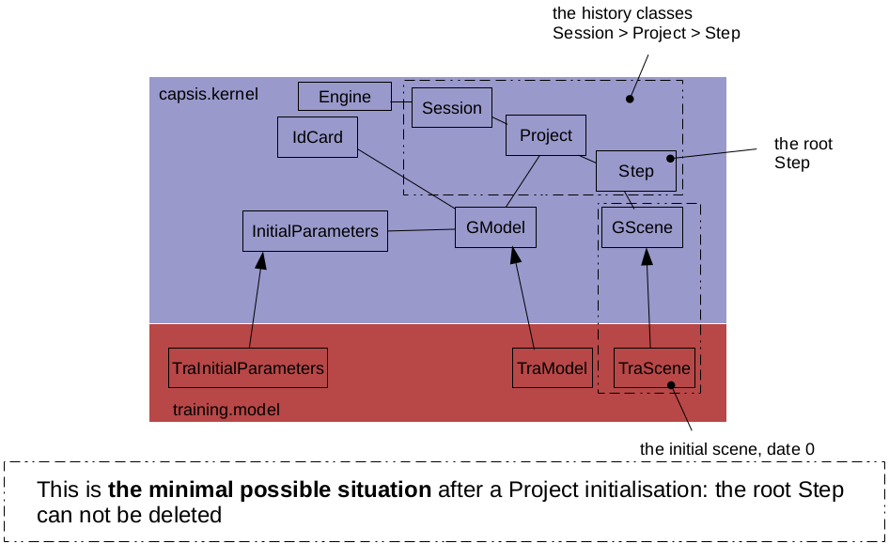
Fig 12: At the end of the model initialisation, the model class has been instanciated with its initial parameters and IdCard, TraInitialParameters.buildInitScene () and TraModel.initializeModel () have been called, the resulting initial scene is stored under the new Project's root Step.

An example of the whole process can be illustrated with C4Script and its superclasses GScript and GScript2 (capsis.script, support for writing scripts for the script pilot, see the Pilot section):

- C4Script s = new C4Script (modelPackageName) calls Engine.loadModel () ;
- initialParameters = new XxxInitialParameters (): to build the InitialParameters object and set its variables values (a specific constructor may be written to load a given fileName) ;
- s.init (initialParameters) calls initialParameters.buildInitScene (), then project = createProject () creates the project and calls model.initializeModel () ;
- The Project is created, with its root Step carrying the root scene as built by buildInitScene ().

Evolution
The evolution process has two stages: getting the evolution parameters, then performing the evolution process. Both operations are done by an exchange between the pilot and the module's relay. Finally, two methods will be called in the module's relay: relay.getEvolutionParameters () and relay.processEvolution ().

The getEvolutionParameters () method is supposed to return a configured EvolutionParameters object (e.g. an instance of TraEvolutionParameters with properties properly set). This object may be very simple and contain only a time limit like a number of years or a target date. It can be more complex and contain options to be considered during the evolution process, like an integrated management strategy. In interactive mode, a dialog box is proposed to the user to set the evolution parameters values. This dialog box has a conventional name: modelpackagename.gui.PrefixEvolutionDialog (e.g. training.gui.TraEvolutionDialog). It must extend EvolutionDialog (capsis.commongui). When found, this dialog will be opened and proposed to the user.

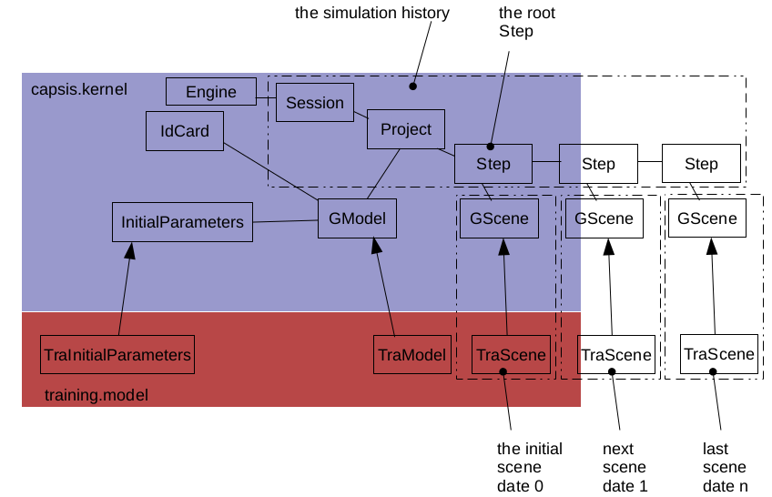
Fig 13: After an evolution was triggerred on the root Step, TraModel.processEvolution () created new instances of the scene at successive dates, and stored them under new Steps linked together.

The main method called at evolution time in the module is finally GModel.processEvolution (), implementing the growth model, looping on time until the time limit is reached and creating new scenes a different dates, added in the project under new Steps. This key method is to be overriden in the module's model class, e.g. TraModel.

Intervention
Interventions were designed to simulate operations or events occurring at a given date and changing the state of the scene. An usual example is a forest management action, e.g. thinning (i.e. removing trees in the scene).

Interventions are extensions. They can be made compatible with one module only, or with several modules by using conventions which can be checked at runtime through Java interfaces, e.g. a forest map viewer could check if the scene is an instance of TreeList (with getTrees ()) and if calling getTrees () returns instances of Tree and Spatialized. If so, the trees can be drawn on a map at their location. This generic viewer would be comptible with several modules (see SVSimple in capsis.extension.standviewer).

All interventions extend Intervener (capsis.kernel.extensiontype), they must override few methods:

- init (GModel model, Step step, GScene scene, Collection c) inits the tool. It is passed the GModel instance linked to the Project, the Step on which the intervention was requested, a copy of the GScene under this step, in which the tool can operate (e.g. remove trees) and which will be linked to the resulting Step, and an optional Collection of objects in the scene, if it is not null, the intervention should be restrained to the objects in this collection (e.g. a sublist of trees in the scene), else the intervention is for the whole scene ;
- initGUI () opens a dialog box and proposes the user to configure the tool interactively, if called, this method must check all the user entries and make sure the parameters have correct values before ending, the method returns true if the tool can be applied (e.g. false if user cancels) ;
- isReadyToApply () runs tests on the tool configuration (variables type, domain, coherence...) to check the tool can be applied, in case of trouble, it is written in the Log and the method returns false ;
- apply () runs the tool, changes the scene passed in init () (e.g. removes trees) and returns the changed scene.

Interveners can be grouped in families (or Intervener subType). Their getSubType () methods returns the name of their subType for this purpose. This name is supposed to be translated through the Capsis Translator (with english and french translations in a couple of files, see the Translator section).

Extensions
Capsis4 has an extensible architecture. An extension is like a plugin, new extensions can be developed at any time. They are part of known extension families. Upon request, they can check their compatibility with a referent object they are passed. They are managed by an ExtensionManager.

On August 23, 2019, there were 1321 extensions available in Capsis4.

ExtensionManager
The CapsisExtensionManager (capsis.app) extends the extension managers superclass in the jeeb-util library: ExtensionManager (jeeb.lib.util.extensionmanager).

It reads an extension list found in etc/extension.list. This file contains extension class names (including their package name), with =true if enabled, and =false if disabled. Disabled extensions are known by the ExtensionManager (allExtensions / enabledExtensions lists) but ignored when extension lists are requested by Capsis.

All extensions extend the Extension class. The extensions are typed. Two maps are used to manage extension types: typeMap (className --> type) and extensionByType (type --> list of classNames).

The extensions may have settings, i.e. instance variables tagged by one of the annotations @Param, @ListParam, @RecursiveParam. They can be stored after user configuration and restored at next opening time. The extensions settings are stored in etc/extension.settings.

The extension managers can be chained. CapsisExtensionManager is chained to the SketchExtensionManager, part of the jeeb.lib.sketch 3D library. Sketch extensions are known and can be managed by the Capsis ExtensionManager.

The compatibility of an extension with a given referent object is checked by the static public boolean matchWith (Object referent) method. This methods checks the given object and returns true if the tool is compatible with it. The type of the referent depends on the type of the extension.

It is possible to add vetoes on some extensions to cancel their compatibility with some particular modules. This can be done through the GraphicalExtensionManager.

The extension families of Capsis are summarized in the table below.

Extension type | Superclass | matchWith (referent) | Number  August 23, 2019
Intervener | capsis.extensiontype.Intervener | an instance of GModel | 130
Memorizer | capsis.kernel.extensiontype.Memorizer | an instance of GModel | 4
GenericTool | capsis.extensiontype.GenericTool | always returns true | 11
DataExtractor | capsis.extensiontype.DataExtractor | an instance of GModel | 650
DataRenderer | capsis.extensiontype.DataRenderer | an instance of DataExtractor | 13
StandViewer | capsis.extensiontype.StandViewer | an instance of GModel | 74
IFormat | capsis.kernel.extensiontype.IFormat | an instance of GModel | 306 *
OFormat | capsis.kernel.extensiontype.OFormat | an instance of GModel | 306 *
Filter | capsis.extensiontype.Filter | a Collection of objects | 19
TreeLoggerImpl | capsis.extensiontype.TreeLoggerImpl | an instance of GModel | 3
EconomicFunction | capsis.extensiontype.EconomicFunction | an instance of EconModel | 7
Lollypop | capsis.extensiontype.Lollypop | an instance of Tree | 4
Spatializer | capsis.defaulttype.Spatializer | specific to the Optimist module | 2
WorkingProcess | capsis.extensiontype.WorkingProcess | a product name (String) | 6
GrouperDisplay | capsis.extensiontype.GrouperDisplay | [Group type, GScene] | 5
ExtractorGroup | capsis.extensiontype.ExtractorGroup | an instance of GModel | 14
* There are 306 (IFormat + OFormat)

GraphicalExtensionManager
The GraphicalExtensionManager is a component of the gui pilot (Tools menu > ExtensionManager), it shows lists of extensions known by the CapsisExtensionManager and proposes to manage their compatibility with the models linked to the opened Projects (for the extension evaluating their compatibility with a model).

When the standard matchwith () method returns true, it is possible to override the decision by adding a veto on the extension for a given model. The extension will not be proposed any more.

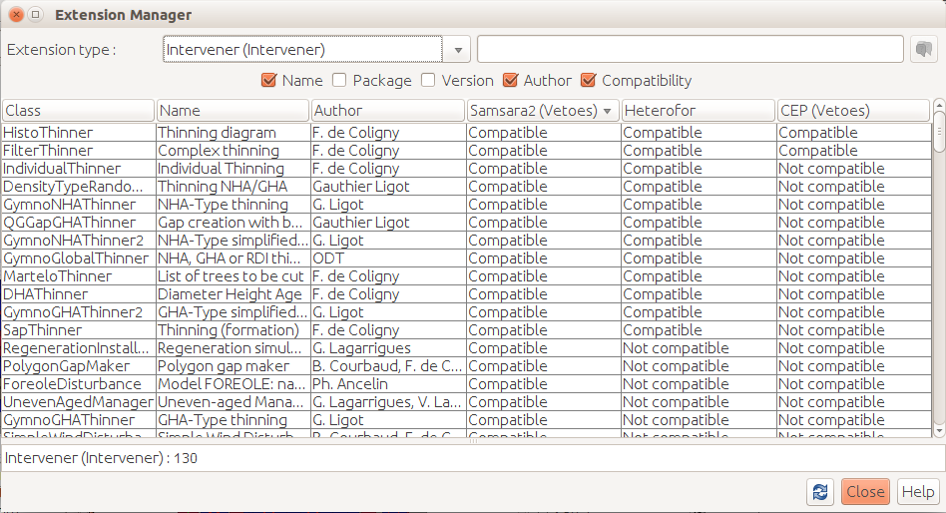
Fig 14: The GraphicalExtensionManager shows all extensions and their compatibility with the loaded modules.

Extension
This is the superinterface of all extensions (jeeb.lib.defaulttype.extension). It declares few management methods for which all extensions must provide implementations.
- getName (): returns the name of the extension (the use of the Translator is mandatory to provide a name in english or in french depending on the decision for the language of the gui pilot at start time) ;
- getAuthor (): name(s) of the author(s) of the extension ;
- getDescription (): short description of the extensions (Translator needed) ;
- getVersion (): version of the extension, e.g. “1.0”, management is let to the authors.

Intervener
The intervention tools are the most important extensions in Capsis, they are used to simulate forest managers actions or other occasional events having consequences on the forest (fires, insect attacks, storms...). They are described in a specific section, see Interventions.
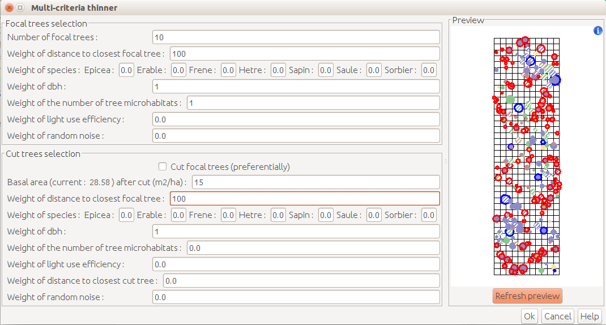
Fig 15: The multi criteria thinner, compatible with the Samsara2 module, cuts trees (in red) relatively to a list of focal trees (in blue).

Memorizer
Memorizers are objects attached to a Project and managing the memory. When Steps are added to the Project, the Memorizer is told and depending on its nature and configuration, it will decide to keep the Step in memory or not. The default one is DefaultMemorizer, it keeps everything in memory. Others use a memorisation frequency or try to keep as little as possible, for very big simulations or for modules managing a lot of bif objects.

GenericTool
A GenericTool is a tool in a dialog box. It is compatible with all referents. In the gui pilot, these tools are grouped in a 'Tools' menu in the main frame. It can be opened at any time by the user.

It needs a single method: init (Window). The given window must be declared as the parent of the dialog to be opened to ensure a good management of the windows chaining and focus.

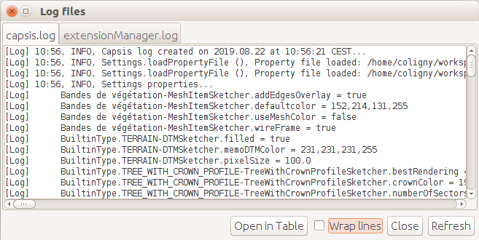
Fig 16: A GenericTool: capsis.extension.generictool.LogBrowserExt shows the log files in var/ to the user.

DataExtractor
A DataExtractor is a tool extracting data series from the simulation history to feed charts. It can be configurable (e.g. class width value for a distribution). It is synchronised on a Step in the Project and can be moved to another Step.

It is associated to a compatible DataRenderer which will show the data series (table, lines, bars...).

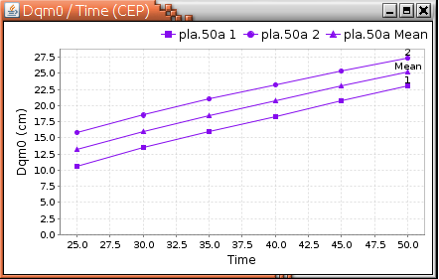
Fig 17: A DataExtractor extracting 3 data series: Dqm0 (cm) / Time for stand 1, stand 2 and mean values. Compatible with the CEP module only. Series are displayed by a DataRenderer drawing lines.

DataRenderer
A DataRenderer is a tool associated to one or several DataExtractors by the intermediary of a DataBlock. A DataBlock (not an extension) contains one or several DataExtractors and a current DataRenderer to show all their data series.

All DataExtractors in the same DataBlock must have same type (i.e. same class), but may be synchronised on various Steps or may be configured differently.

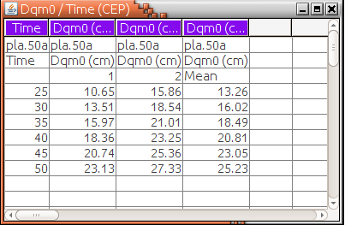
Fig 18: Same DataExtractor than previous figure, but in a DataRenderer showing data in a table.

The DataExtractors may have common or individual configuration. The DataRenderer may have its own configuration. E.g. all DataExtractors in the block may be switched to 'hectare mode', and one only could be configured to restrict to a given group of trees.

The DataRenderer may be switched to another one if compatible with the DataExtractors in the block (e.g. histogram to table).

StandViewer
A StandViewer is a tool showing the scene under a given Step. It can be a drawing (e.g. a top view map), a table, or any other representation.

Unlike DataExtractors, they are limited to one Step. To see several scenes at different dates, the user will have to open several StandViewers, each synchronised on a different Step.

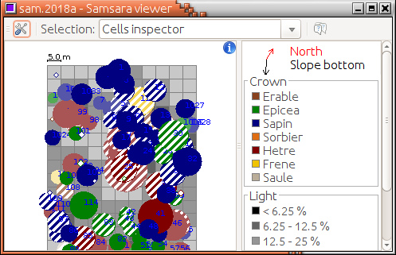
Fig 19: A graphical StandViewer for the Samsara2 module.

ObjectViewer
These tools show an object (or a list of objects) in a Panel. Generally, ObjectViewers draw graphical representations, but they can draw anything (e.g. a table). They are available from other tools where elementary selection is possible. E.g. the StandViewers drawing or listing individual trees may propose to open an ObjectViewer on the selection.

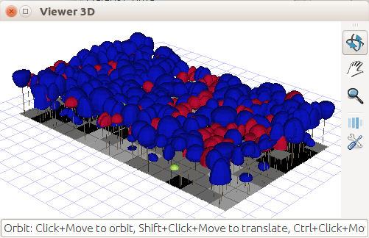
Fig 20: The 3D viewer is an ObjectViewer drawing a 3D representation of a scene. It can be adapted to all modules with individuals (here: a whole Heterofor scene). The 3D drawing is an interpretation of the scene, can be customized.

IFormat, OFormat
These are extensions for input and output: file loading and exporting.

IFormat has a method: GScene load (GModel). This method loads a file and builds a GScene instance. It is used for many 'inventory files' in Capsis module, i.e. the tool used in InitialParameters.buildInitScene () to build the initial scene of the simulation.

OFormat is for exporting a GScene instance. It can be used in export extensions. It is configured by initExport (GModel, Step) to tell if it will work on the scene under the given step, and triggerred by save (fileName).

A utility class called StandRecorSet (capsis.util) extends both IFormat and OFormat, it is a helper class to build tools able to load and save scene from / to disk.

In interactive mode, the Export command in the ProjectManager's StepPopup opens a dialog box with all the OFormat extensions compatible with the model of the Project to let the user export the scene under the Step in a file.

ModelTool
These tools can be opened on a step and do something on the attached scene. The difference with the Intervener is: they do not create a new Step in the Project.

These tools can be used to run an analysis and show results before closing.

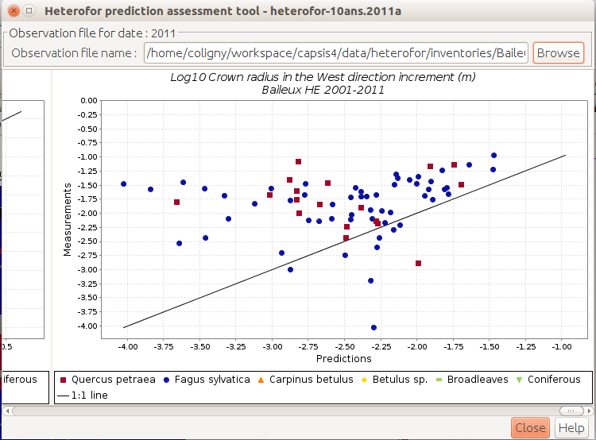
Fig 21: The Prediction Assessment Model Tool for the Heterofor module.

Other extension types

Filter may be used to filter lists of objects. They can be configured and are used by the Capsis4 grouping system.

TreeLoggerImpl is an interface for tools simulating tree logging.

EconomicFunction can be an Income or an Expense, used to evaluate the economics balance of a scenario (related to the capsis.lib.economics library).

Lollypop draws trees like lollypops in a 2D viewer.

Spatializers are a specific feature of the Optimist module. It has a getAvatar (TreeList) method returning a list of TreeAvatar. TreeAvatars are a simple representation (for drawing) of a tree and its crown.

WorkingProcess tools process input products and create output products (related to the Regix module) in a forest exploitation and transformation scenario.

GrouperDisplay is a graphical component showing selected elements in a scene a group creation time.

ExtractorGroup proposes to open a list of DataExtractors on a given Step.

Standard features

PathManager
Capsis4 proposes an operating system independent way to find the paths under capsis4/, wherever Capsis was installed. The PathManager (jeeb.lib.util) class contains static methods for this purpose.

- PathManager.getInstallDir () will return the installDir of Capsis, e.g. /home/coligny/workspace/capsis4/ ;
- PathManager.getDir (directoryName) returns the path of the given directory, e.g. PathManager.getDir (“data”) may return /home/coligny/workspace/capsis4/data/ under Linux, or C:\capsis4\data\ under Windows. For available directories under capsis4/, see the Architecture on disk section.

Settings storing and restoring
Capsis proposes a standardised way to store and restore settings, the Settings class (jeeb.lib.util):

- Settings.setProperty (propertyName, value) saves the property’s value ;
- Settings.getProperty (propertyName, defaultValue) gets the previously saved value for the property, or returns the given default value if the property was not yet saved by setProperty () ;
- these two methods have overloaded version for various types of value / defaultValue: boolean, int, double, String… ;
- a file is loaded at the beginning by Settings.loadPropertyFile () (in Options.init ()) and stored by calling Settings.savePropertyFile (), in particular at Capsis closing time in the interactive pilot (Quit command, in capsis.commongui.command) ;
- the option file for Capsis is PathManager.getDir("etc") + "/capsis.options" ;
- any tool in Capsis may use this system to manage its configuration.

Log
Capsis has a standard log management system, based on the Log class. All methods can write in the Capsis log file (var/capsis.log) which is deleted at Capsis start time, by using the static methods in Log:

- Log.println (message) prints the message in the log file as an information ;
- Log.println (type, sourceMethod, message, throwable) specifies the type (e.g. Log.WARNING, Log.ERROR), the sourceMethod (e.g. TraModel.processEvolution ()), a message in english and a throwable (e.g. the reference to an exception which was raised) ;
- a list a of methods are provided with various combinations of the previous list of parameters (in case there is no exception...) ;
- Log.println (logName, message) prints the message in the log named logName.log in var/. If the log does not exists, it is created on the fly. Other methods writing to logName are provided with various combinations of parameters like Log.println ().

Translator
Capsis official language is english. All source codes and documentations are written in english. French is the secondary language, just for the graphical user interface (gui pilot). To translate the labels and other texts appearing on the Capsis main frame and dialogs, Capsis proposes the Translator class:

- the target language is the language decided at launch time (e.g. capsis -l fr launches Capsis interactive mode in french) ;
- Translator.addBundle (language.bundle.file) loads the file in english or french with the specified language.bundle.file: language.bundle.file_en.properties or language.bundle.file_fr.properties (relying on a Java convention) ;
- it is a good practice to set addBundle () in a static initializer of the class: it will be executed the first time and only once ;
- Translator.swap (“ClassName.someMessage”) will return a translation of the given key in english or french ;
- the convention for the key is 'NameOfTheClassWeAreIn.explicitMessage”. In case the translation is not found, Translator.swap () will return the key. It will be visible on the graphical interface, the explicit message will be understable and it will be clear what key is missing a translation in what class, and the correction will be easy ;
- all texts showing in the user interface must be translated with the Translator and a couple of files must be provided for english and french translations ;
- it is possible to propose other languages for specific module, but this would lead to bilingual graphical user interfaces because all the labels in the Capsis generic user interface are only english / french, so this is discouraged ;
- all modellers must provide english and french translations for their keys, except the non french speakers who may copy the english translations as is in the english file ;
- these conventions imply that writing directly a text without using the Translator on the graphical user interface is an error which needs correction.

Groups
Some modules handle elements in their scenes (e.g. individual trees). It is possible to tell Capsis about these elements to benefit from the Grouping system features:

- the Scene object must implement the PossiblyGroupableScene interface: such a Scene will be able to return the GroupableTypes it handles and return the elements for a given type ;
- GroupableType instances must be provided by the module, with for each a key (not translated) and a name (i.e. Translator.swap (key)) ;
- all elements to be managed in groups must implement GroupableElement and return their type on demand ;

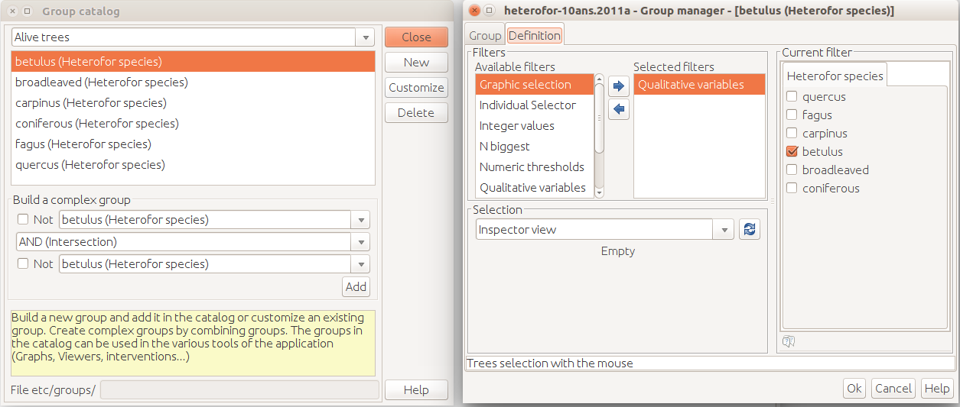
Fig 22: The GrouperCatalog for the Heterofor module shows the available Groupers. Customize opens the GrouperDefiner and displays the selected Grouper's current configuration.

The Group class is a central hub for Groups managing: it can be asked a number of questions, it relies on the upper interfaces to answer:

- isGroupable(GScene scene) returns true if the Scene can be grouped ;
- Collection<GroupableType> getPossibleTypes(GScene scene) returns the GroupableTypes of this Scene ;
- GroupableType whichType(Object individual) returns the GroupableType of the individual ;
- Collection<GroupableElement> whichCollection(GScene scene, GroupableType type) returns the collection matching the type in the scene.

Based on these basic features, the Groupers framework makes it possible to build tools to filter the elements:

- Grouper is a super interface for tools able to buid groups, it has a name, can return the type of the elements it can handle, a matchWith () method taking a collection and returning true if the elements inside can be handled, and has an apply (collection, not) method returning a GroupCollection with the elements it selected in the given collection (a true value for not is to ask the complementary) ;
- The GrouperManager knows all the groupers (loaded from a file at start time), it can be used to get all the Grouper instances or their names, or just for a given type, or compatible with a given element, it can return a Grouper given its name, it can load or save the Groupers in files ;
- GrouperCatalog (interactive) shows the known groupers ;
- GrouperDefiner (interactive) helps the user build groupers ;
- GroupableIntevener is an interface for Intervener objects which can be applied on a subset of elements of the scene (e.g. cut trees only for a given species).

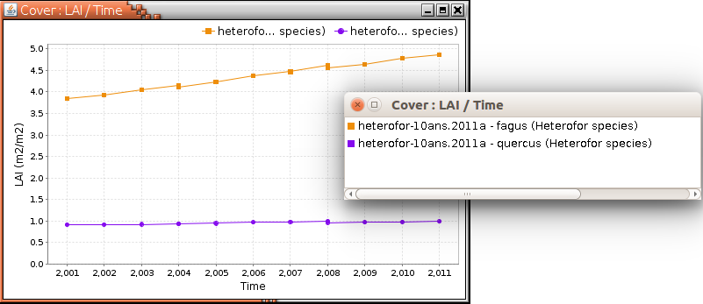
Fig 23: Using groups in DataExtractors: orange line was configured on the fagus species and the violet line on quercus.

Some Groupers:

- Identifier selects the elements with a given set of ids ;
- DummyGrouper returns the collection without any selection ;
- Filtrer selects the elements retained by all the Filters inside ;
- ComplexGrouper selects the elements according to two Groupers combined by a logical AND or OR.

MethodProvider
A MethodProvider is an object attached to a GModel. It is optional and my be null. If not null, it must extends MethodProvider (capsis.kernel).

A MethodProvider object implements methods which can be detected by conventional interfaces in capsis.util.methodprovider. E.g. the GProvider interface defines public double getG (GScene stand, Collection trees). All MethodProviders implementing the interface will provide the method and will return the basal area (G, m2) of the GScene it is given, or if the collection is not null, the basal area of the trees in the collection (conventional). The MethodProvider is part of a module, it knows the scene data structure of the module and can answer correctly.

If another module provides the same feature, the basal area of the two modules will be comparable. Some tools rely on MethodProviders for their compatibility with modules, by testing the MethodProvider attached to the GModel instance (mp = model.getMethodProvider (); if (mp != null && mp instanceof GProvider) return true;)

Some DataExtractors rely on this system and make comparisons possible.

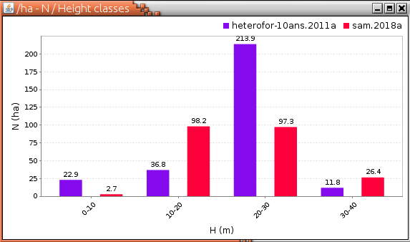
Fig 24: Comparison of height distributions for two modules in the same DataExtractor. Compatibility is evaluated by using capsis.kernel or capsis.util.methodprovider interfaces.

File organisation

Architecture on disk
Capsis is installed in an install directory (which suggested name is capsis4/), hereafter called capsis4/. This directory contains particular directories and files:

- src/ contains all the source codes in directories matching the class packages, e.g. the classes in the capsis.kernel package will be in src/capsis/kernel/ ;
- class/ contains the result of the compilation process, see the Compilation commands section ;
- etc/ contains configuration files ;
- etc/diagramlists/ contains the lists of diagrams the user built (if any) from the Capsis graphical user interface (gui pilot) ;
- etc/groupers/ contains the groupers the user built (if any) through the Grouping system ;
- ext/ contains the external libraries which can be used in Capsis, they are in .jar files ;
- ext/linux/, linux64/, windows/, windows64/, macosx/ contain native code for Linux, Windows and macOS (sometimes in 32 / 64 bits versions) which was made accessible to Capsis, but more often .dll or .so (dynamic link libraries / shared objects) added to be linked with a particular Capsis module (e.g. etc/windows/ORG*.dll files for Organon) ;
- var/ contains the files with a variable size, in particular the log files, including capsis.log ;
- tmp/ is there for saving projects and other exportation files (they can be saved elsewhere) ;
- data/ contains example data for running simulations with the modules, each module may have a directory with its name in data for example files, e.g. data/pp3/ ;
- doc/ contains the html documentaion pages when built with javadoc (see the Compilation and other commands section) ;
- test/ contains source codes related to testing.

Special files

Capsis4 needs several special files to work, some of them have already been mentioned in other sections, here is a summary:

- etc/capsis.models is the list of models for the ModelManager (model package names) ;
- etc/capsis.properties is loaded at start time, contains values for expected properties, e.g. the Capsis web site URL or the R home directory ;
- etc/capsis.options contains all the user preferences (size and location of the dialog boxes, colors, various options) ;
- etc/extension.list is the list of extensions for the ExtensionManager (class names) ;
- etc/extension.settings contains the user preferences related to the extensions configuration ;
- build.xml is the configuration file for the ant tool (see the Compilation section) ;
- installer*.xml are configuration files to help build custom installers ;
- javalibrarypath is a file containing technical file paths to help Capsis find the dynamic link libraries in ext/. If missing, the capsis script will create it ;
- License.txt is the text of the Capsis license (english) ;
- memory is a file generated by the setmem script and used by the capsis script at launch time ;
- Readme.txt is a file with information on Capsis4 ;
- revision is written by the compilation command (using revision.template), it is the maximum SVN revision number found in all the classes of Capsis4, e.g. 14661, see revision.readme.

Scripts
All scripts delivered with Capsis are in the capsis4/ installation directory and they must be launched from this directory. The default way is to open a terminal, to change directory to the install directory (generally named capsis4/: cd .../capsis4), then to type the name of the script to be launched.

The script names ending by .bat are for Windows, to launch capsis.bat, just type capsis. The script names ending by .sh are for Linux and macOS, an easy way to launch them without having to change their permission to executable is for example for capsis.sh to type sh capsis.sh.

- capsis: the script to launch Capsis4, see the options with capsis -h ;
- capsis-en is a shortcut to easily launch Capsis in interactive mode and english ;
- ant: a shortcut to an embedded version of ant, a tool to automatize actions, see the Compilation section ;
- checkCompilingJarDependencies.sh is a technical tool for developers ;
- setmem makes it possible to tune the amount of memory (memory heap: where the objects are stored at runtime) Capsis4 will require from the operating system. This value is for the Java Virtual Machine and Capsis, it must be lower than the available memory on the system, an amount of memory might be reserved by the operating system and the other running applications, setting a too big value under Windows may prevent Capsis from starting, Capsis will never require more than this memory amount from the operating system, default values are provided for the usual configurations, setmem values are in Mega bytes.

Libraries
The libraries developed by Capsis4 modelers / developers are stored in the capsis.lib package. These libraries are under the terms of the Capsis free licence (LGPL) and can be used by all modellers.

Additional external libraries were embedded in Capsis (in ext/ .jar files), their features can also be used by all the modellers in their source code.

Technical libraries:

- args4j is used by Capsis to interpret the arguments passed at launch time ;
- groovy-all contains the Groovy language features ;
- jeeb-util and jeeb-formats bring common features in Java for the AMAP lab projects ;
- jeeb-sketch is the AMAP lab 3D library used by Capsis for all its 3D viewers ;
- jfreechart is used for the charts in Capsis ;
- jogl* is the Java Open GL binding, used by the Sketch library ;
- vecmath is a vector and matrix library ;
- commons-math is an Apache library for statistics and mathematics, widely used in Capsis ;
- gt-* is the GeoTools library bringing Geographical Information Systems functions ;
- ...

Functional libraries:

- frozen libraries may be found in ext/ : they are archives of a capsis.lib.library with a keyword added, built by a Capsis command (ant freeze...) and on which a module has been redirected to decouple it temporarily from the original library which may be unstable because still under development, e.g. capsis-lib-castanea2019january.jar ;
- repicea.jar and mrnf-foresttools.jar are libraries developed by Mathieu Fortin and used in several Quebecker models ;
- lerfob-foresttools.jar are libraries developed by the former Lerfob lab in Nancy (now called Silva) for their models in Capsis ;
- phreeqc-29oct2015.jar is an implementation of the PhreeqC model (USGS), connected to the Heterofor module ;
- ...

Project saving on disk
Capsis proposes an automatic way to save the projects on disk. The Project saving methods rely on the Java serialization, which follows all the references from the Project object to be saved to find all the objects to be stored, and stores them in a binary format based on the matching class description.

The fields not to be followed are declared transient. This way, a Capsis Project can be stored, with the linked GModel, its InitialParameters and IdCard, and all the Steps and the connected GScene instances in the simulation.

Once reloaded by the complementary method, all the objects will be restored with the same state. It will be possible to continue the simulations with all the configuration restored.

Note: changing a class means changing the format and will prevent restoring the previously saved projects.

The Capsis charter
[This section was copied from the official Capsis charter text on the Capsis web site: http://www.inra.fr/capsis/charter]

Goals
This charter defines the rules between the Capsis project actors, it must be accepted by all partners, it aims at :

- Flexibility,
- Easing the synergies,
- Set everyone at his level of competence,
- Ensure the intellectual property of the partners,
- Provide a clear working framework.

Different actors
- Developers are in charge of the project, they manage the application kernel (architecture, design, maintenance, evolutions…) and the generic aspects. They propose training courses, support and animation.
- Modellers are the authors of the models to be integrated into Capsis. They are responsible for the actual development, with the training and assistance from the developers.
- End-users may use some models in Capsis. They interact with the modellers with who they are in contact.

Developers and Modellers are part of the Capsis co-development community.

Capsis charter
- Free kernel: the Capsis4 kernel is a free software ( licence) : kernel + generic pilots + extensions + libraries (all the capsis.* packages).
- Development: the modellers are in charge of the development of their models into Capsis.
- Support: They can have support from the developers : training sessions, design, starting help, further assistance.
- Free access in the community: All the source codes are freely accessible by all members in the Capsis community, modules may become the base for new modules, code can be shared…
- Respect of intellectual property: all members respect the intellectual property of the other members.
- Validations: developers deal with technical validation, modellers deal with functionnal validation.
- Distribution: the stabilized / validated modules may be distributed when the author decides and chooses a license ( free license suggested), possible download from a ftp site.
- Decentralization: modellers manage directly the relations with their end-users: financing, training, assistance, models documentation, contracts…

To comply with the charter, the modellers may distribute the Capsis platform with their own modules but NOT with the modules of the other modellers. The modules (i.e. the growth models) are indeed not free and belong to their authors who may decide to distribute them with the license they choose. The section 4 of the charter grants access on all the modules to the modellers of the Capsis community but only to them, resulting in this distribution restriction.

References

Dufour-Kowalski S., Courbaud B., Dreyfus P., Meredieu C., de Coligny F., 2012. Capsis: an open software framework and community for forest growth modelling. Annals of Forest Science (2012) 69:221–233

